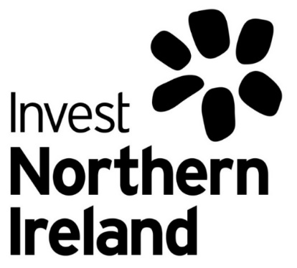

SEEKING AN EXPERIENCED GREEN GROWTH PROFESSIONAL FOR SECONDMENT TO INVEST NI

Green Growth Executive

(GGE/22)

Closing Date:

9 June 2022
AT 12:00 NOON BST

Invest NI recognises the increasing significance of the Green Economy as a key driver of growth and prosperity and has recently established a Green Growth Team in line with the Department for the Economy’s 10X Economy – An Economic Vision for a Decade of Innovation. The Green Growth Team seeks to ensure that Northern Ireland capitalises on the opportunities arising from the Green Economy, primarily by developing and implementing Invest NI’s Strategic Plan for growing a Green Economy in NI and enabling companies to take advantage of the opportunities in new markets.

Invest NI is now seeking to attract a high calibre individual on secondment to support the development of a Green Growth road map to build out the NI proposition to exploit emerging opportunities in the Green Economy.

ABOUT THE OPPORTUNITY

The Green Growth Executive will be responsible for supporting the Green Growth Team in prioritising opportunities for business development mapped to NI company capability. This will include assessing how NI businesses can pivot and engage with the Green Economy, developing top priority capabilities for the Green Economy, advising on programmes of work to raise awareness of opportunities in target sectors and clusters, and plan for customer outreach for FDI and Trade activity.

You will work to develop plans to roll out green growth activity on behalf of Invest NI, with particular focus on next steps for pursuing upcoming Green Growth opportunities and identifying diversification opportunities in emerging green markets. This will also include consideration of scoping priority capabilities and identifying clustering opportunities to take advantage of the emerging opportunities in the Green Economy. You will also advise on the steps needed to position NI Green Growth capability and assets in a trade and FDI context.

You will work with the Green Growth Team and Sector Teams to support the mapping of action plans to enable NI businesses to capitalise on Green Growth opportunities.
The secondment opportunity will last until March 2023 and secondment arrangements will be agreed between Invest NI, the external company and the individual.

WHAT WE ARE LOOKING FOR

Invest NI is seeking a secondee with significant knowledge, experience and skills in the core elements of Green Growth, as well as effective relationship management, oral and written communication and presentation skills. A full personnel specification and outline of the key responsibilities of the role can be found at the end of the document.

INTERESTED? HERE’S WHAT TO DO NEXT

If you feel that this opportunity might benefit your organisation and nominated individuals, please liaise with your Human Resources or approving department on how best to take it forward. If your firm is interested in nominating a staff member for this development opportunity, you should arrange for the nominee to forward a covering letter of not more than one side of A4 in length and a CV of not more than three sides of A4 to the Invest NI monitoring office quoting ref GGE/22 at monitoringofficer@investni.com

Applicants should demonstrate their suitability against the Personnel Specification provided.

It is envisaged that Invest NI will meet with those applicants who most closely match the skills requirements as demonstrated on their CV and covering letter before finalising any secondment arrangements. Applications must be received no later than 12 Noon on 9 June 2022. It is envisaged that the selection process will be completed within two weeks of the closing date.

Should you wish to discuss this opportunity further, please contact David Waring — Human Resources Business Partner on 028 9069 8311.

Green Growth Executive – Secondment Role:

Key Responsibilities:

Reporting to the Head of Green Growth, the main responsibilities of the role will include:

- Development of plans to roll out a Green Growth road map;

- Development of plans to identify top priority capabilities for the Green Economy;

- Carrying out assessment of opportunity identification in the Green Economy and building out next steps to support Trade and FDI activity;

- Presenting comprehensive written proposals to Senior Management in support of required business cases to achieve expenditure approval;

- Participating in Client, Sector and Strategic teams within Invest NI;

- Preparing advice, briefings and information for Senior Management, the Invest NI Executive Board and Ministers as required.

Personnel Specification:

Company nominations are invited for individuals who are in a position to be seconded and who can demonstrate they have knowledge, experience and skills in the following areas;

- Recent experience of working within a Green Growth or Green Economy context, preparing reports for management;

- Recent experience of analysing business and market related information and presenting recommendations for clients or management;

- Recent experience of preparing business plans or proposals for senior management or customers in a business environment;

- Experience of effective oral and written communication and presentation skills;

- Experience of using strong customer focussed relationships with
key influencers or decision makers to deliver mutually beneficial results.

Recent is defined as within the last eight years

Secondment:

It is expected that the secondment will begin as soon as possible and will last for a period to 31 March 2023, however shorter periods would be considered.

The Secondee will remain employed by their organisation during the period of the secondment on their current terms and conditions but Invest NI will cover actual salary and related costs to an agreed maximum per annum.

